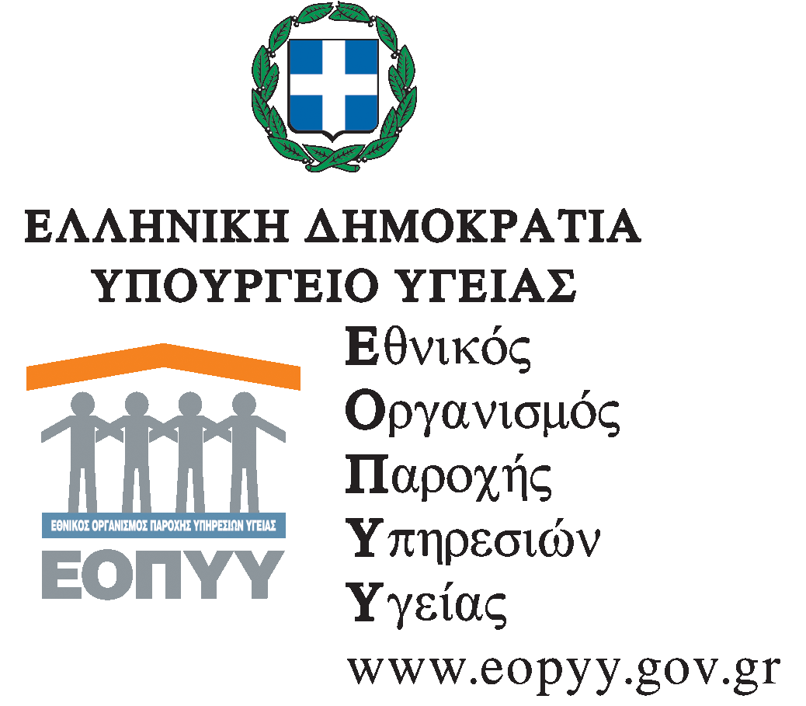 | Athens, 15 November 2012
 | Protocol number: 47563
General Headship: Planning and Development  Of Health Services | TO  1. Hellenic Federation of Pharmaceutical Industries  Kifissias Ave. & 3, Agriniou Str., 152 32, Halandri, Athens, Greece  2. Hellenic Union of Pharmaceutical Industries  Lampsa Ave. 3, 11524 Ampelokipi  NOTIFICATION  - President Office  - Vice President Office  - Department of Economic Issues
Medicine Department
Department of Pharmaceutical Policy
Information: E. Alexopoulou
Τel.:210-6871718 Fax: 210-6871792
Address: Κηφισίας 39, 151 23 Μαρούσι
E-mail: d6@eopyy.gov.gr

Θέμα: «Rebate amount to EOPYYs pharmacies»

According to Law Ν. 4093/2012 (Governance Newspaper Sheet 222, Volume A, November 12, 2012), paragraph ΙΒ.2, paragraph 8, it is established a return amount (rebate) for pharmaceutical companies or Marketing Authorisation Holders towards National Organisation for Health Care Services Provision (EOΠΥΥ) as well. The above amount is represents the 5% of the Hospital Price as the Hospital Price is defined by the current legal framework. The rebate amount will be calculated upon purchasement invoice.
As the above term has to be implemented retrospectively from 1st of January 2012, EOΠYYs’ pharmacies suppliers-companies should issue credit invoices towards ΕΟΠΥΥ. For that reason, every company will receive relative letter with the corresponding amount until the end of November of 2012.

EOΠYY PRESIDENT  E. PAPAGEORGOPOULOS | Ο ΠΡΟΕΔΡΟΣ Ε.Ο.Π.Υ.Υ.  Γ.ΒΟΥΔΟΥΡΗΣ

