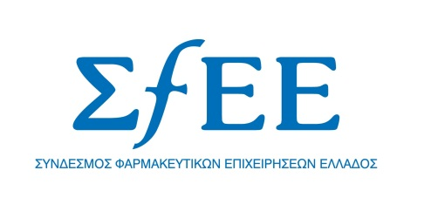

RESOLUTION
OF THE GENERAL ASSEMBLY OF SFEE

Athens, September 25, 2012

The pharmaceutical industry in our country has always provided, despite the adverse circumstances, a high level of healthcare to the Greek citizens. It also contributes to the growth of our national economy and employment, offering thousands of jobs to scientists and other highly-qualified professionals. It generates government revenue worth hundreds of million euros, through investments, taxes and social contributions. It exports medicinal products to more than 100 countries across the globe.

Today, at a very critical juncture for our country, the general assembly of SFEE was held and unanimously agreed on the following:

After successive political failures, the situation in the healthcare sector has now come to an impasse. The State owes €1.8 billion to pharmaceutical companies, which effectively have not received any payment since 2006. In the meantime, arrears are accumulating, which are not settled as stipulated by law.

Moreover, the settlement of arrears from the 2007-2009 period resulted in the haircut on the pharma bonds, leaving the industry with a loss of €1 billion, for which we demand compensation.

Amid this stifling environment, the government is unilaterally attempting to implement an untransparent claw-back mechanism, which is set to deal a final blow to the already struggling pharmaceutical companies. This is enough! Our member companies cannot take it any more! They have appealed against the measure before the Council of State and they are not willing to proceed with its payment. They cannot continue to supply the State on credit forever and, on top of that, be required to pay claw-back and rebates. This is not their role. Nor is it the role of the State to disregard its own enacted laws and corrective measures or to systematically avoid honouring its commitments.

In an ultimate effort, SFEE demands an urgent appointment with the Prime Minister. It is imperative that the issue of healthcare provision to the Greek citizens, their access to necessary treatments and employment in the sector be taken up to the highest possible level.

