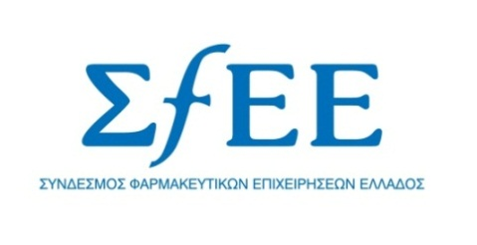

PRESS RELEASE

The pharmaceutical expenditure is under control.
The launch of new innovative medicinal products is feasible.
Athens, June 20, 2013 - As regards the evolution of the public pharmaceutical expenditure and according to the latest data, pharmaceutical expenditure for the first five months of this year, is under control with a controllable excess of €36 million. In fact, according to estimates and the progress of May’s expenditure, which was lower than the Memorandum’s objectives, the total pharmaceutical expenditure is anticipated by the end of the year to close within €2.44 billion, which is the goal set by the Memorandum.
Considering the pharma industry’s firm and consistent stance, the continuous collaboration with the Government and the competent Ministry and the visible by now results in containing the expenditure, it is imperative to allow within the coming weeks the introduction of new innovative medicines in the Greek market. After all the political leadership, according to the latest statements, has demonstrated its positive disposition in this direction and therefore Greek patients must gain immediate access to innovative therapies, which relate to serious medical conditions such as metastatic prostate cancer, chronic myelogenous leukemia, metastatic melanoma, Hepatitis C, pulmonary hypertension, nodular sclerosis, cystic fibrosis and other rare diseases. It is noted that no innovative medicine has been priced for 2.5 years’ time.

