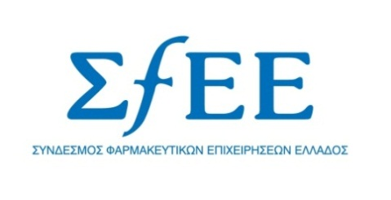

Press release
IKA blocks payments of its arrears to pharmaceutical companies
Athens, 5 June 2013 - A serious and unwarranted setback has emerged in respect of the payment of IKA’s arrears to pharmaceutical companies. Although IKA has the funds available to proceed with the immediate settlement of all its outstanding debts since 2010, the whole process has stalled and IKA still owes about €260 million to pharmaceutical companies!
At a time when the market as a whole is being suffocated by the protracted delay in the payment of arrears, the cumbersome public administration uses lame excuses to freeze payments, despite the orders it has received from the Minister of Health and the Minister of Finance, as well as from the Prime Minister himself, to speed up the payment procedures.
SFEE wishes to inform its members and the public at large that payments to pharmaceutical companies have halted, on the grounds that pharma companies are not explicitly mentioned as healthcare providers and therefore payments to them cannot be approved! In short, pharmaceutical companies are not considered to be healthcare providers!
The problem lies in how some people interpret legislation. More specifically, the relevant laws (4038/2012 and 4132/2013) refer to the payment of arrears by social security funds “to pharmacies and other contracted private healthcare providers (doctors, clinics, diagnostic centres and laboratories, etc.)”. Thus, as pharmaceutical companies are not specifically referred to in this sentence, some argue that such companies are excluded from the scope of this provision (!!!) and therefore the payments of IKA arrears to them cannot be approved! However, the Ministerial Decisions that have been issued in implementation of these laws explicitly mention the pharmaceutical companies as healthcare providers, and even impose, in their case, a discount of about 2% on payments of arrears.
It should be noted that the total outstanding debts of the public sector to pharmaceutical companies have come close to about 1.6 billion over the past two years and that, despite the government’s objective to prevent the build-up of a new generation of arrears, unpaid invoices for 2013 have already begun to accumulate, currently amounting to nearly €380 million!

